REGISTRATION AND
SPONSORSHIP PAYMENTS

GOLF REGISTRATION FEE INCLUDES:
- 18 holes of Golf with Cart
- Box Lunch
- Buffet Dinner
- Practice Range 9:30-10:45 AM
- Putting/Hole Contests
- Prizes & Trophies

Rates: Early Bird by 8/1 After 8/1 Total: Foursome: X $400 x $420 =_____ Singles: ____X $100 __x $105 =

Dinner only & 10 Raffle Tickets: $30 =
Can’t make it but I’d like to donate: $

Sponsor Opportunities – Please circle:

Sponsorship Opportunities & Benefits Join the Fun! Save! Showcase your company or organization to more than 144 golfers with packages that include sponsor recognition on the course, in the clubhouse, on the Delafield Legion’s website and in the Delafield American Legion’s Newsletter.

SOLE SPONSORSHIPS

- Practice Range Sponsor – show your support by your company’s signage for all golfers to see while warming up for the day’s events $ 150

Raffle & Prize Sponsor
SPONSORSHIP OPPORTUNITIES
Can’t join us? Showcase your business and support by donating a prize item for the Raffle. All sponsors will be listed in all event medium and in the Delafield American Legion newsletter.

CO-SPONSORSHIPS:

- Lunch Sponsor: includes golf for two, recognition at the event, signage at the event, opportunity to address lunch attendees. $ 350**

EVENT RESERVATIONS
Checks payable to and mail form(s) to: Delafield American Legion Post 196

333 N. Lapham Peak Rd
Delafield, WI 53018

Questions - contact Mike Proulx at 262.844.5198 or email:

mproulx@wi.rr.com

Payment must accompany the reservation form. Reply EARLY! Limited to the first 144 golfers.

Foursome Contact Information:

(see next pages for full details)
- Practice Range $ 150
- Putting Contest $ 150

- Putting Contest Sponsor – Includes lunch and dinner and signage at the putting contest. You can attend

- Dinner Sponsor – Sponsorship includes golf for two,

Name: Address:
___________________________________
__________________________________
___________________________________

Tee Sponsor $ 100
- Par 3 Sponsors each $ 200
- Birdie Sponsor $ 650
Co-Sponsor Opportunities:
o
and work this contest! $ 150

- Tee Sponsor - your signage on a hole of your choice (multiples available – choose early & showcase your company at the event!) $ 100
recognition at the event, signage at dinner,
opportunity to address dinner attendees.

- Cart Sponsor – (choose early)

$ 350**
Phone: (______) ______________

Player’s names

Golfer 1 __________________________________

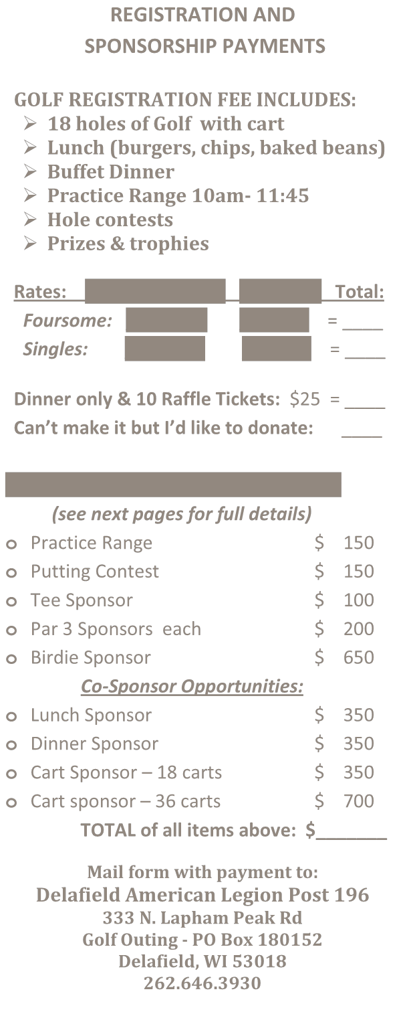Lunch Sponsor $ 350
- Dinner Sponsor $ 350
- Cart Sponsor – 18 carts $ 350
- Cart sponsor – 36 carts $ 700
TOTAL of all items above: $

Mail form with payment to:
Delafield American Legion Post 196
Golf Outing
333 N. Lapham Peak Rd
Delafield, WI 53018
262-844-5198
Mike Proulx

- Par 3 Sponsors - 4 holes available - your signage on a hole of your choice – choose early & showcase your company at the event! $ 200

- Birdie - Includes on-course presence & golf! Show- case your company on a hole of your choice; 4 golf packages, plus dinner & lunch for up to two additional representatives. Also includes signage & recognition at event. $ 650
  - 18 carts $ 250
  - 36 carts $ 500

** Sole sponsorships vs co-sponsorships are also available per option (lunch or dinner). Contact the legion early to arrange for this opportunity.
Email __________________________________
Golfer 2 __________________________________
Email __________________________________
Golfer 3 _________________________________
Email __________________________________
Golfer 4 __________________________________
Email __________________________________

Our Mission:

The Delafield American Legion Post 196
Was chartered on January 8, 1923 as a patriotic veteran’s organization devoted to mutual helpfulness.
It is part of the nation’s largest veterans’ non- profit 501 (c) (19)
organization, committed to mentoring and sponsorship of youth programs in
our communities, advocating patriotism and honor, promoting a strong national security, and continued devotion to our fellow service members and veterans.
Delafield American Legion Post 196
10th Annual Golf Outing Fundraiser

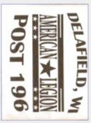
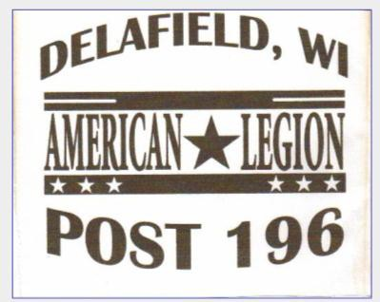
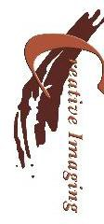
Friday, August 27th, 2021
Delafield Legion Post 196 333 N Lapham Peak Rd Golf Outing - PO Box 152 Delafield, WI 53018
262.646.3930
A special thank you to our brochure sponsor:
Creative Imaging Products LLC www.creima.com

Delafield Legion Post 196

10th Annual Golf Outing Fundraiser
Friday, August 27th, 2021
Broadlands Golf Club
18 Augusta Way, North Prairie, WI 53153
262.392.6320
www.broadlandsgolfclub.com

LINE UP YOUR FOURSOME TODAY!

Scramble format – All players hit their own balls, but play from best lie. Singles, doubles, men, women, co-ed teams- All Welcome!

SCHEDULE:

9:30 -10:45 AM Registration, Driving
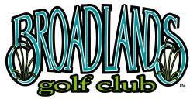
Range & Box Lunch
11:00 AM Shotgun Start
4:00-4:45PM Cocktails
4:45 – 7PM Dinner, Auction & Raffles

