**THE AMERICAN LEGION POST 196**

Delafield Post No. 196

**November**

**2022**

333 Lapham Peak Road

Delafield, Wisconsin 53018

|  |
| --- |
| Meetings: **Clubhouse Opens:**  **About 1 hour before Business Meetings**  **Legion / 3rd Monday**  November 21 1900 hrs  **Sons/ 1st Monday**  November 7 1830 hrs  **Auxiliary/ 2nd Monday**  November 14, 1830 hrs |

The World’s Largest Veteran Organization

Post 196

Delafield, Wisconsin,

###### “The Spirit of 196”

Clubhouse phone - 262-646-3930

**The American Legion**



# 

**Commander’s message for November 2022**

Hello Legion Family Members,

      As November is upon us, I would like to thank you all for your support for the legion.   We are having record breaking sales at the bar and all of our Family events are being very well supported and attended.   Our new addition is looking good. Just reminder to pardon the dust as we get to the finish line.

Last month we had our 15 Annual Car show. Even with the unexpected rain that came, we still had 113 cars and tons of support for the bar and food sales.  Thank you to the BoySscouts for providing breakfast.  A week later, the Son’s had their annual Packer Tailgate party outdoors. Even though the Packers did not win, the event was well attended and the weather couldn’t have been any better.

Next Saturday Nov. 5th is the Auxiliary’s Wine tasting event. There are tickets for sale at the bar if you are interested in going.

If you haven’t heard, once again, we are having our 96th Annual Coon feed on the last Saturday in January the 28th.  I will be chairing this event along with Nick Corgiat.   A big thank you to Zach from St. Johns for getting the approval once again to use the cooking facilities at the academy.   We are asking that members help out with donations. Frozen turkeys, ham, raffle prizes, or anything you can donate would help tremendously. Please start donating now if you can.  In years past we were a little short of raffle items and we want to get out to a good start this year.

I hope everyone has a happy thanksgiving and see you soon

God’s blessings

Terry Frazier Commander Pot 196



**SONS OF THE AMERICAN LEGION SQUADRON 196**

**(The Sons had nothing to repost for November)**

**AMERICAN LEGION AUXILIARY**

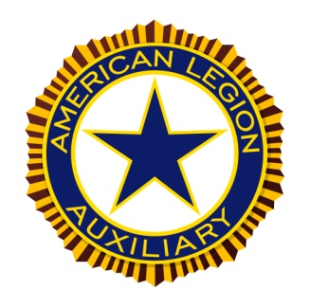

With Fall being a very slow time at the Post, it was decided to postpone our cookie baking until Dec. 6 and then we will be baking and bringing cookies once a week, every Tuesday. Our cookie sales have been very popular all summer long with all the activities, so we hope to continue next Summer.  After the first of the year, we will decide how often we will bring cookies during the Winter months. Thank you to everyone for making this a successful event!

The distribution of the combined funds from the Ducks, “Rock With the Vet”s and “Parkerfest”, were agreed upon. The recipients and amounts are:

The Building Fund - $5000

Custom Canines - $2500 (this will give us an opportunity to name one of the dogs)

Boy Scout Troop 49 - $1000

Knit Wits - $300

Wreaths Across America - $150 for 10 wreaths

ALA County Project to make tie blankets - $100

The November 5, Wine Tasting event is fast approaching! This is a fun event and hope to see you there. Please consider donating a bottle or more of wine with a $10 or more value, your favorite appetizer, raffle items for the raffle baskets. You can drop off your donated wine and raffle items at the post any time before Oct. 29 with notes that they are for the Wine Tasting. Any appetizers can be brought in the evening before or after 9:00 am the day of. If your food item needs to be heated, please include the directions. Make sure to put your name on your serving dishes so they can be returned.

November 11 is Veterans Day! Thank a vet and remember those who are no longer with us.

REMINDER: Your 2023 dues are due. $30 for members, $6 Junior membership under 18. Make checks payable to ALA Unit 196 and send to Sue Schiller, 1463 Heather Cir., Hubertus, WI 53033.

For God And Country!

**Jane Schmittinger**

**President, American Legion Auxiliary, Delafield Unit 196**

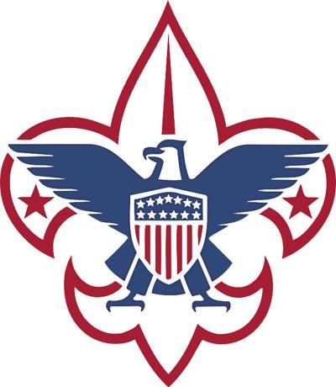

Troop 49 Report

11/2/2022

1. Scouts attended the co-ed Devils Lake campout, enjoyed hiking around the lake on different trails, cooking in the outdoors and a nightly dance.
2. Helped Pack 49 at a Cub Scout event they put on. Scouts worked with compass courses, first aid, tent setup, knot tying, leave no trace, hiking skills and scout safety.
3. Donna Finch setup the George Finch Eagle Scout Memorial Fund that is designed to help support Eagle Scout projects for Troop 20, Troop 49B and Troop 49G. Thank you for your kind support.
4. Upcoming events, Okpik Winter Training, Fall Camp-O-Ree at Camp Long Lake, Troop elections next month.

Service to our community:

* Pack 49 instruction: 8 scouts, 4 adults, 30 hrs.
* Cooking at the car show: 3 scouts, 2 adults, 25 hrs.

Total: 11 scouts, 6 adults, 55 hrs

Respectfully submitted,

Ed Marek – T49 Charter Org Rep

Chaplain’s Corner

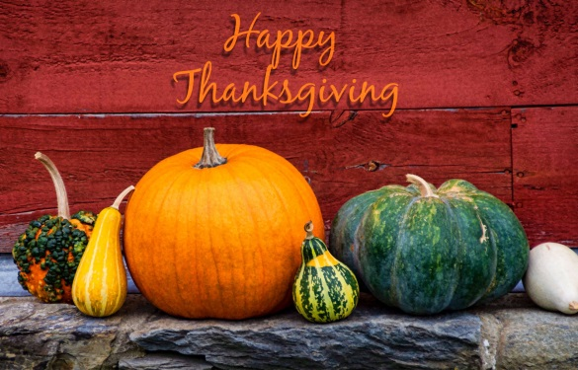

November 2022

We gather together to thank God for all the events and things we have in this world. As a Legion we have:

* Almost a new building addition
* Increased interest in our Clubhouse
* Our Scouts are happy and active
* Sons continue to be successful in fund raising for the Vets
* Our Auxiliary is way about average
* Mike walking almost OK
* Our Coon Feed is on again with the help of Terry and Nick
* Lost too many good friends and members
* Celebrated ducks, poppies, golf, fishing and other successful fund raisers
* Achieved 100% + membership
* Elected and replaced officers for all our family

This list could go on and on, but I think you get the general idea, Thank God for everything good and not so good. November reminds us that old man winter is coming, so we need to be ready. I am reminded of an old hymn that sums up my fillings on this holiday. Let us be thankful for all we have been Blessed with in this life.

Come, ye thankful people, come,  
Raise the song of harvest home;  
All is safely gathered in,  
Ere the winter storms begin;  
God our Maker doth provide  
For our wants to be supplied;  
Come to God’s own temple, come,  
Raise the song of harvest home.

Remember your Chaplains are here for you, and please contact us if we can be of service to you.

Your Chaplains are:

Contact the Legion Chaplain – Neil Rand at (262) 646-3126 [nrand@wi.rr.com](mailto:nrand@wi.rr.com)

Contact the SAL Chaplain – Tom Kerwin at (262) 370-7450 [tkerwin@wi.rr.com](mailto:tkerwin@wi.rr.com)

Contact the Auxiliary Chaplain – Barbara Doerfer at (414) 333-4891 [jbedoerfer@gmail.com](mailto:jbedoerfer@gmail.com)

We have scheduled fund raisers, musical entertainment and other events for your enjoyment. Take a look at the events coming up !!



**Events Coming Up!**

**Saturday Nov.5th – Wine tasting**

**Saturday Nov.19th – Comedy Club**

Watch the weekly emails for activities at the post every week!!!

**PLEASE HELP US GET THE WORD OUT!! VOLUNTEERS NEEDED FOR MANY EVENTS!!**

THE PUBLIC IS WELCOME!!! (That’s Legion terms for Open to the Public)

TUESDAY-FRIDAY 4PM

FOOD, BEVERAGES AND COMARADERIE !!!!

BRING YOUR FRIENDS AND ENJOY - WE WOULD LOVE YOUR COMPANY



ALWAYS KEEP CURRENT WITH POST 196 AND SCAN ABOVE TO YOUR SMART PHONE ☺

Check us out on FACEBOOK Delafield Legion Post 196 and “LIKE “ us - www.delafieldlegion.com

**EDITOR’S NOTES:**

We had a FREE band jam on Oct.30th. Some great music was played with songs from classic rock to country western. I only wish more people from the legion would have been in attendance. Hopefully with the new hall expansion, we have a better turnout from members of our post.

If you are looking to rent the legion hall, pavilion, or baseball field, please contact me or call the post and leave a message.

If anyone is still getting a paper copy of this newsletter and would like to receive it either through email or go online to our website to read it, let me know. I can help you get to the website or I can get to you added to email if you have an address. Newsletters will be provided at the post for the Delafield members, so you can pick up a paper copy there. I will still send a paper copy to those that are physically unable to pick one up. If you have a Delafield address and you are unable to pick a newsletter up at the post, you can contact me by email at [GOLDFAT@AOL.COM](mailto:GOLDFAT@AOL.COM) or by phone 262-695-0555

Thank you,Keith “Buff” Roeber - 2nd Vice Commander - DELAFIELD AMERICAN LEGION POST 196